COLT ANALYTICS PLATFORM
High Level Design
CONFIDENTIAL


Document Information

Version History
Version | Date | Description
1.0 | 10-September-2018 | First version prepared by SAP
1.4 | 19-September-2018 | Parts 7.8, 7.8.1, 7.8.2 updated following the sizing trial
1.5 | 24-September-2018 | Part 7.7.4 updated to prioritise DT over scale-out
1.6 | 25-September-2018 | Various parts as per discussion

Document Author
Name | Role
Adeel Sundhu (SAP) | SAP Solution Architect
Swati Saxena (SAP) | SAP Technical Architect
Oleg Filippov (SAP) | SAP Technical Architect
Ashish Aitiwadekar (SAP) | SAP Solution Architect

Contributors
Name | Role
Pirjo Hiltunen (SAP) | SAP Solution Architect

Approvers
Name | Role | Evidence Link | Date of Approval

For Distribution
Name | Role | Version

 | List all approvers for the document, and insert a link to the evidence of approval (Ctrl+K) for audit.

Table of ContentS
1 Document Information 2
1.1 Version History 2
1.2 Document Author 2
1.3 Contributors 2
1.4 Approvers 2
1.5 For Distribution 2
2 References 5
2.1 Documents 5
2.2 SAP Notes 5
2.3 Glossary of Terms 5
3 Introduction 6
3.1 Project Summary 6
3.2 Scope 6
4 Executive summary 7
5 Solution Architecture 8
5.1 Subject Areas in scope of BI Analytics: 8
6 Technical Solution “As-Is” 9
7 Proposed (“To-Be”) approach 12
7.1 Assumptions & Dependencies 12
7.2 Proposed Target Architecture 12
7.2.1 Phase 1- Minimal Disruptive approach - Transitional stage 12
7.2.2 Risks and mitigations 14
7.2.3 Phase 2 - Final Proposed Architecture 15
7.2.4 Data Provisioning 16
7.2.4.1 Enterprise Information Management(EIM) 17
7.2.4.2 Smart Data Integration (SDI) 19
7.2.4.3 SAP HANA Data Provisioning Adapters 19
7.2.5 Modelling 20
7.2.5.1 Layered Architecture 21
7.2.5.2 Schema Structure 22
7.2.5.3 Package Structure 23
7.2.5.4 Design Patterns 24
7.2.6 SAP Data Hub 25
7.2.7 Agile Data Preparation (ADP) 26
7.2.8 Visualization Layer 27
7.2.9 Risks and mitigations 28
7.3 Hosting Options 28
7.4 Networking 29
7.4.1 Assumptions, risks and mitigations 29
7.5 Virtualization 29
7.5.1 Assumptions, risks and mitigations 30
7.6 HA/DR (Availability and Continuity) 30
7.7 Scalability 32
7.7.1 Load/Unload a Column Table into/from Memory 33
7.7.2 Table partitioning 33
7.7.3 Dynamic Tiering 34
7.7.4 Proposed approach 35
7.7.5 Assumptions, risks and mitigations 35
7.8 Sizing 35
7.8.1 Proposed approach 35
7.8.2 Assumptions, risks and mitigations 36
7.9 Tiers 36
7.9.1 Proposed approach 36
7.9.2 Assumptions, risks and mitigations 36
7.10 Lifecycle Management 37
7.10.1 Proposed approach 37
7.10.2 Infrastructure Security 37
7.10.3 Assumptions, risks and mitigations 37
7.11 Authentication & Authorization 37
7.11.1 Authentication and single sign-on 37
7.11.2 User and identity management 37
7.11.3 Authorizations 38
7.11.3.1 As-Is process 38
7.11.3.2 To-Be process 38
7.11.3.3 Analytic Privileges 39
7.11.3.4 Data Masking 39
8 Business Use Case in scope of High Level Design: 39
8.1 Snapshot reporting in SAP HANA (BI) 39
8.1.1 Reporting on source system data using SAP HANA (BI) 40
8.2 Persistence Layer 40
8.3 Query Processing 41
8.4 Building virtual data models 41
8.5 Reporting and Visualizations 41
Table of figures

Figure 1. As-Is High Level Architecture 9
Figure 2. As-Is L1 Solution Diagram (Subject areas) 10
Figure 3. As-Is L1 Solution Diagram (non-Subject areas) 11
Figure 4. Proposed Target Architecture (transitional phase) 13
Figure 5. Proposed target Architecture (short term) 15
Figure 6. Proposed target Architecture 16
Figure 7. ETL Tool Comparison 16
Figure 8.. EIM Component Overview 18
Figure 9..SDI Technical Architecture 19
Figure 10. Modelling components view 20
Figure 11. Modelling Principles 21
Figure 12. Layered Architecture 22
Figure 13. SAP Data Hub – SDI, SDQ, BODS, ADP relationship 26
Figure 14. SAP Analytics Cloud – Connection Environment 28
Figure 15. SAP HANA virtualization options 30
Figure 16. SAP HANA HA/DR options 31
Figure 17. SAP HANA HA for scale-out 32
Figure 18. SAP HANA Scalability 35

References

Documents
Document | Last Update | Document Version | Author
BI_Solution_Architecture_Plan_V0.1.docx | 11-07-18 | 0.1 | Colt
Netezza_DB_Information.xlsx | 19-07-18 | NA | Colt
Feed_Details_Inbound_Outbound.xlsx | 30-07-18 | NA | Colt
2018_09_17_Entity_Analysis.xlsx | 17-09-2018 | NA | Colt

SAP Notes
ID | Note
1788665 | SAP HANA Support for virtualized / partitioned (multi-tenant) environments

Glossary of Terms
ID | Description
SDI | Smart Data Integration
SDA | Smart Data Access
DP | Data Provisioning
ODP | Operational Data Provisioning
DWH, DW | Data Warehouse
DT | Dynamic Tiering
ALM | Application Lifecycle Manager
DWF, SAP HDW | Data Warehouse
NDSO | Native Datastore Object
ADP | Agile Data Preparation
SAC | SAP Analytics Cloud

Introduction

Project Summary
Colt are considering migrating from IBM Netezza based to SAP HANA based Business Intelligence solution
The purpose of this document is to provide a description of the system components for the proposed Colt BI solution and how these components fit together.
The objective of the document is to provide decision points regarding deployment and migration options, security, system software, and integration both from technical and functional perspectives.
The System Blueprint (Blueprint) evolves throughout the project and becomes a key component of the final documentation for the system.

Scope
The scope of the document covers high level design and decision rationale for the following areas:
- Hosting
- Networks / Communication
- Virtualization
- Scalability
- High Availability / Disaster recovery
- Sizing
- Software Logistics
- Security
- Integration / Data Sources
- Data Migration and modeling approaches
- Front End Services

Executive summary
Following discussions taken place during workshops held at Colt offices on the 17-19 July 2018 and further review of the available documentation, SAP proposed migration approach from IBM Netezza based Data Warehouse to SAP HANA based Data Warehouse. Various deployment options were discussed and are described in this document.
The proposal is to adopt staged migration, where Netezza and HANA database are running in parallel while applications are transitioned into HANA to minimize the disruption and familiarize with SAP HANA data warehouse operation
During the first phase the existing ETL layer will be used to load data to HANA and Netezza in parallel, some adjustments will be required to align ETL flows with HANA structures. The same applies to HANA models, the logic of Netezza models will be duplicated with necessary modifications/ use of modelling Artefacts to enable consumption for reporting and outbound interfaces.
As the target architecture, the proposal is to migrate ETL layer and Xtrac/IRT calculating engines into SAP HANA and maximize the usage of HANA modelling artefacts to utilize potential offered by SAP HANA, the proposed Options and recommendations are discussed further in the document.
Although the ETL tools mentioned for target architecture provide the Automation capability of data movement within the HANA environment, SAP recommends considering SAP Data Hub for enterprise wide integration and automation of the data processing.
Based on initial sizing assessment, SAP HANA can be deployed as scale-up 4.6TB system with Dynamic Tiering for CRD-Raw data; further scalability options are discussed and decision points with proposed approaches are documented.
Suggested High Availability and Disaster Recovery options of the HANA based solution will provide same or RTO/RPO as current Netezza based solution.

Solution Architecture
Reporting and Analytics is often described as the process of increasing the competitive advantage of a business by intelligent use of available data in decision making. COLT’s Reporting and Analytics High Level Design will be applied to promote consistent and normalized information as an enabler for business improvement, and to leverage the standard SAP HANA architecture structures to:
Solve the problem of fragmented data which includes multiple department-specific data marts and stove piped “islands” of data
Improve data quality and conformity by aligning different projects and groups that use similar data, and enhance overall efficiency of data analysis
The Reporting and Analytics High Level Design will encompass the development of an Organizational Analytical environment to support the strategic, tactical, and operational reporting requirements of COLT at Organizational and divisional levels.
Provides a comprehensive approach on how to settle and deploy a Reporting and Analytic enterprise data warehouse.

Subject Areas in scope of BI Analytics:
The following subject areas would be introduced to the solution landscape as part of this transformation.
- Accounting (Revenue Data)
- Campaigns
- Corporate Data
- Inventory
- Invoicing
- Involve Party – Master Data
- Location
- Products (Not part of the diagram, but discussed during the call)
- Services assurance
- Service usage
- Service orders

Technical Solution “As-Is”
At a high level the current BI architecture is the following:
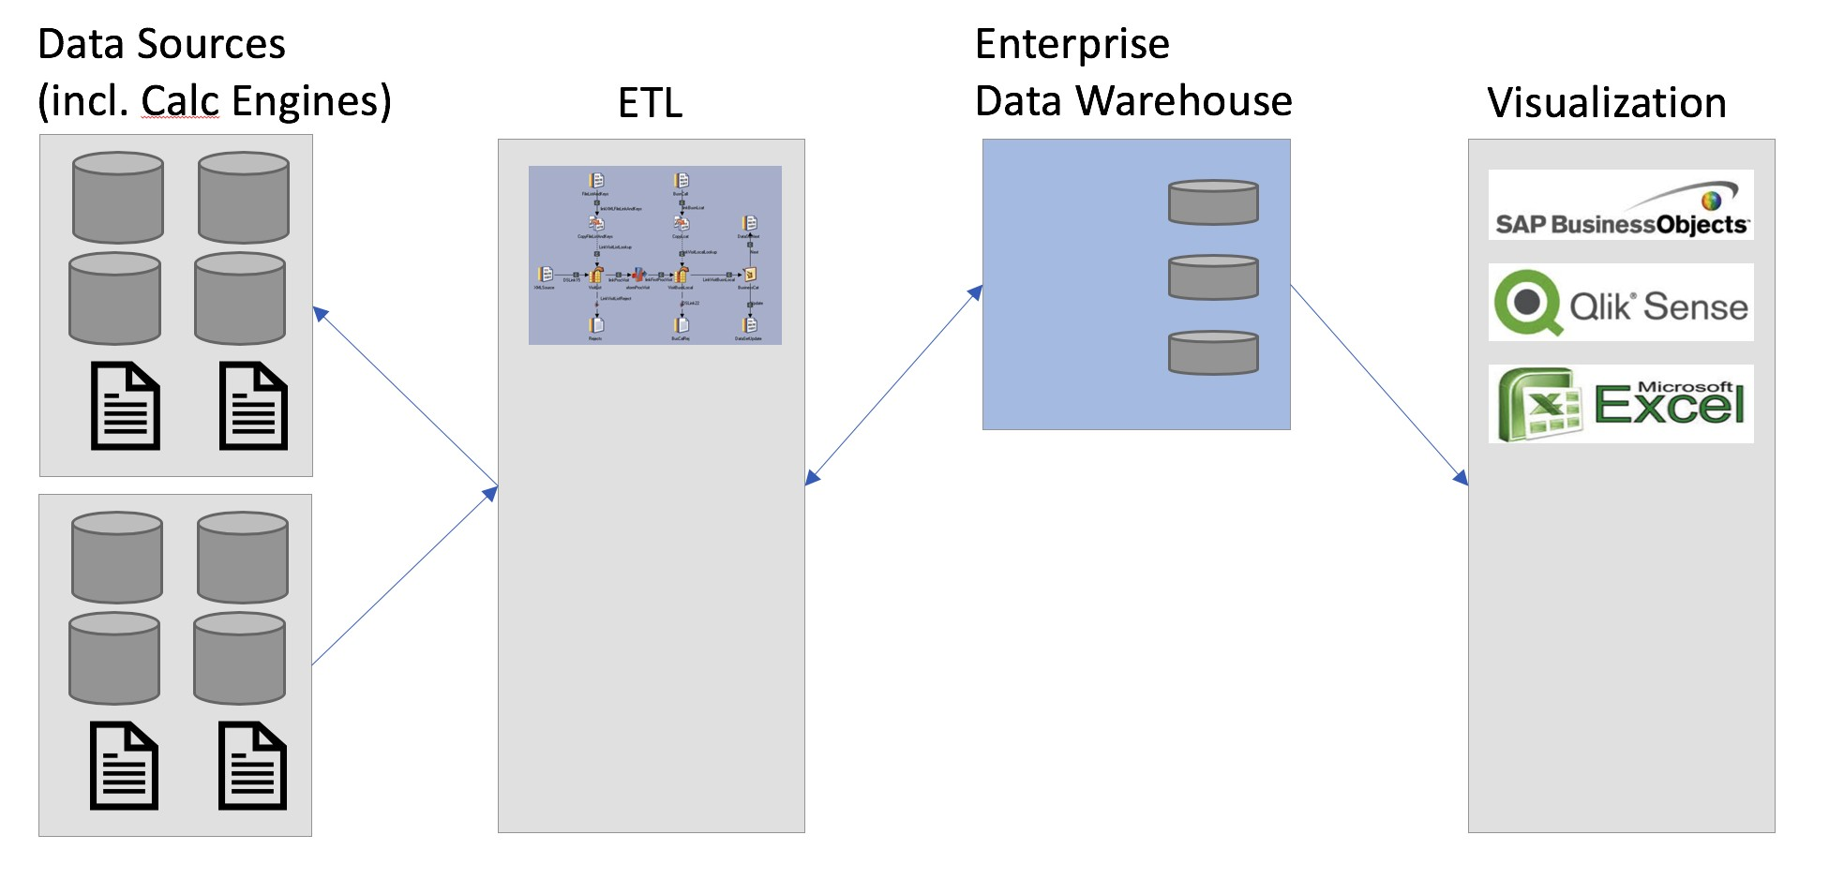
Figure 1. As-Is High Level Architecture
- IBM InfoSphere DataStage is used as ETL tool for inbound / outbound interfaces
- There are 41 source interfaces: (27 inbound / 14 outbound). Different Sources like Database (Oracle, Sql-server etc.), Files (CSV), Web Services (REST Based API, SOAP Based API) – more details can be found in Feed_Details_Inbound_Outbound.xlsx spreadsheet)
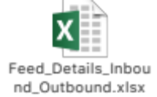
- IBM Netezza is used as Enterprise Data Warehouse
- Two calculation (Xtrac – Oracle based and IRT – MS SQL Server based) engines are used to capture data from IBM Netezza (via ETL layer); the data is transformed and enriched as part of the calculation engine functionality; the transformed data is fed back to IBM Netezza for reporting. In addition, more reporting is done directly from calculation engine datasets
- No full data sets are replicated from the relevant data sources; only selected sets, supported by delta enabled processes, necessary for reporting are loaded into Netezza Data Warehouse.
- Above data captured in L1 dataset
- Further L2 / L3 dataset created wherever required
- Typically, data load is performed out of working hours daily
- Snapshot creation jobs typically run monthly
- Business Objects / Qlik / MS Excel are used for visualization
- Power analytics users have direct access to Netezza for data discovery
- Colt BI landscape comprise of three tiers – Development, Test and Production
- High Availability is provided via IBM Netezza blade architecture. No Disaster Recovery system is currently available.
At present data is replicated from to a multitude of data sources and transformed / enriched based on the Telco data model where data is captured in eight different subject area databases.
Application databases are created for reporting purpose and contain only logical views; segregation into separate Application databases provides additional security.
The following diagram represents L1 data architecture for Subject areas of the current solution (source - BI_Solution_Architecture_Plan_V0.1.docx):
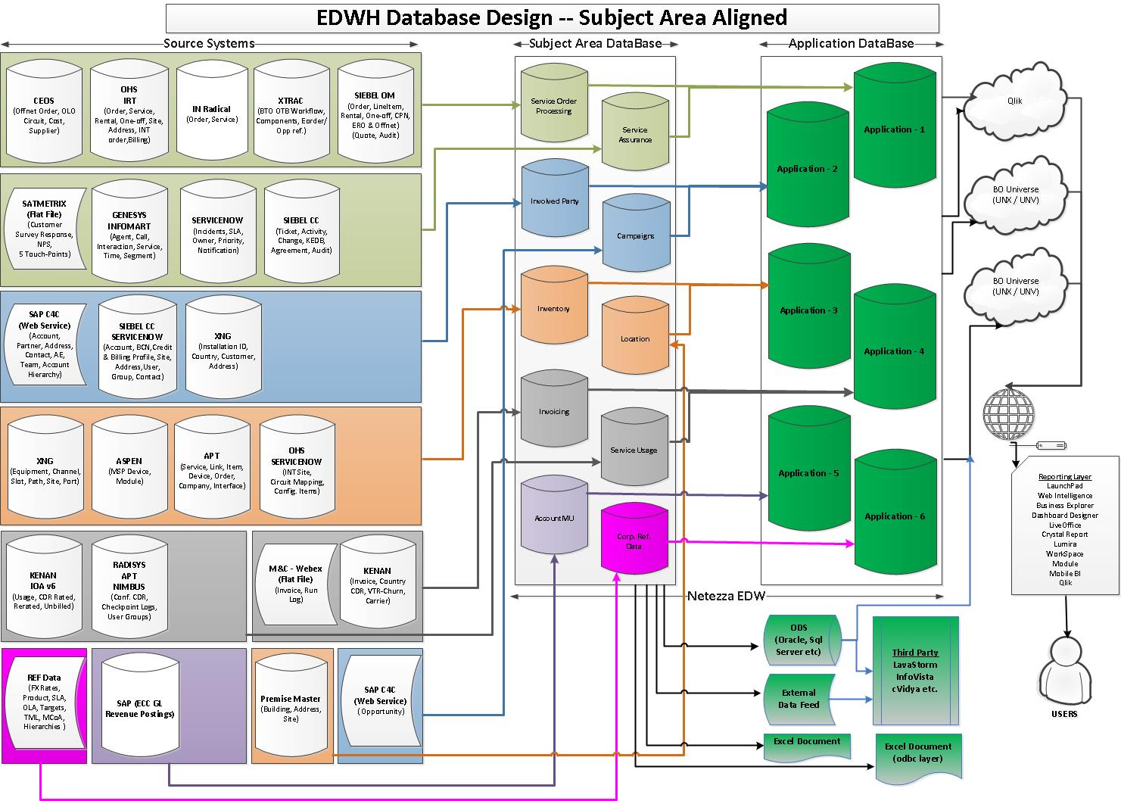
Figure 2. As-Is L1 Solution Diagram (Subject areas)
In addition to subject area databases, several non-subject area databases are created. These are used to store data where volumes are high (like billing).

The following diagram represents L1 data architecture for non-Subject areas of the current solution (source - BI_Solution_Architecture_Plan_V0.1.docx):
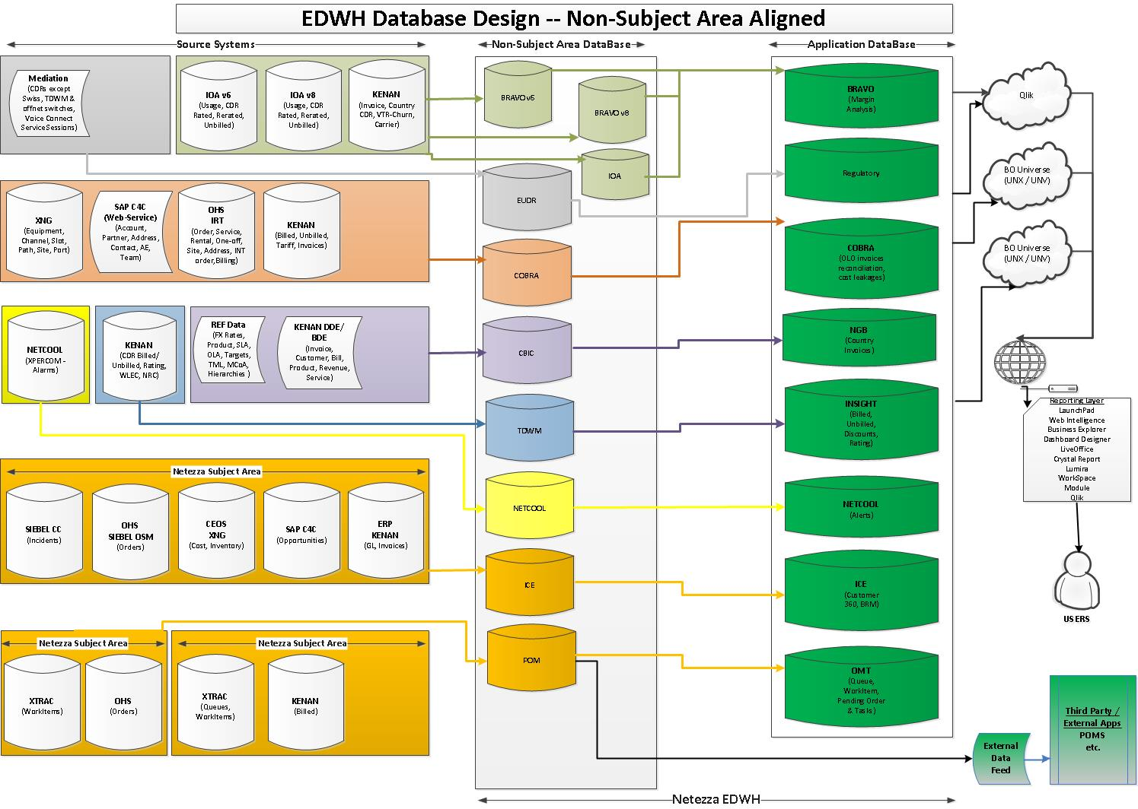
Figure 3. As-Is L1 Solution Diagram (non-Subject areas)
More details on current data model available from the referenced BI_Solution_Architecture_Plan_V0.1.docx document.
The data (including historical data) is currently staged in Netezza database.
All reporting is done against Netezza; no logical views connected directly to the sources are used to avoid impact on the source systems.
Authentication into the Data Warehouse is done via userid / password; authorizations are managed at Business Objects and Netezza (using built hierarchies) levels.

Proposed (“To-Be”) approach

Assumptions & Dependencies
SAP held a workshop with Colt on the 17-19 July 2018 to discuss technical and functional requirements for the Data Warehouse.
The following assumptions & dependencies have been made by SAP when preparing this document as an outcome from the workshop & follow-on discussions:
- Database sizing will have significant impact on the technical architecture.
- “Lift and Shift” approach to be used where possible to minimize migration disruption.
- For the target architecture, ETL logic and Xtrac/IRT calculating engines to be migrated to HANA and DWH data L2 and L3 model to be reviewed to utilize SAP HANA capabilities
- SAP HANA 2.0 is the proposed replacement for IBM Netezza.
- IBM InfoSphere DataStage integration with SAP HANA will need to be validated to confirm functional and performance suitability. The view is that IBM InfoSphere DataStage will remain as ETL tool during the first phase. Other options to be considered when / if IBM InfoSphere DataStage confirmed as not a suitable tool to operate with SAP HANA based Data Warehouse
- Both On-Premise and Cloud deployment models can be considered

Proposed Target Architecture
As the current DW is productive and has complex functions COLT has decided to follow two phased approach

Phase 1- Minimal Disruptive approach - Transitional stage
At this stage the proposal is to keep existing InfoSphere DataStage as ETL and to install SAP HANA database to run in parallel with IBM Netezza database.
- No change to existing data model.
- Where possible duplicate the data structures in HANA DB as they are currently in Netezza.
- Consider using HANA artefacts for special cases or for replacement of DB views with script-based object types.
- Leverage IBM DS to Load source data into HANA and transform data within HANA DB Currently approx. 5000+ tables identified in total.
- Generate target structures in HANA like Netezza – To be consumed by Qlik, BO, Excel
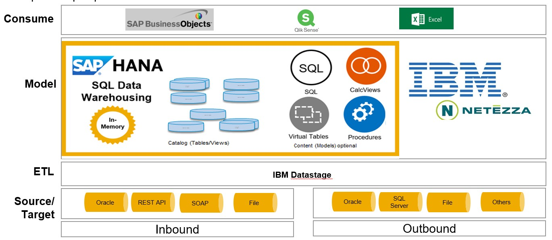
Figure 4. Proposed Target Architecture (transitional phase)
ETL – IBM DataStage
Connection type: ODBC
Assumption: ETL supports two target Databases.

Inbound Data: Extract, Transform and Load source data to target HANA DB and Netezza.
- IBM DataStage will be the ETL tool to Load, Transform the data for the Reporting requirements.

Inbound
 | Data Type matching | ETL Generated Code | Free hand SQL used for ETL | Null Handling
Datastage | Expect challenges | Approx.70% Compatibility expected | Needs investigation | Validate against Netezza
Outbound Data: Extract the data out of the HANA DB and Netezza for outbound requirements.
- IBM Data Stage retrieve data from the HANA Artefacts, HANA table, HANA DB views

Outbound | Retrieving from SAP HANA
 | Data Type matching | DB tables | DB View Access | HANA Views | HANA Procedures
Datastage | Expect challenges | Yes | Yes | Yes | Yes

Migration:
Data Migration is the key for the project, following two options can be considered
Option 1 – Single table for Migration and daily feeds
- Create HANA DB tables as replica of Netezza tables
- Load data using Netezza to HANA DB tables
- Check for the Delta logic after Migration – Switch to datastage, alternatively create Separate jobs
  - Data Migration – Netezza to SAP HANA
  - Via Datastage to SAP HANA

Option 2 – Separate table for Migration and daily feeds – Recommended due to flexibility
- Create HANA DB tables as replica of Netezza tables – 1 For Migration, 1 for Daily feeds
- Load data using Netezza to HANA DB tables in Migration table using DataStage 1:1 mapping
- The Daily feed table should be populated using DataStage with source data
- Create a HANA DB view (union) to combine Migration + Daily feed data –
  - Phase 2 can utilize the same concept in a HANA calculation view
  - This will also help in Archiving in the long term
Modelling:
Although SAP recommends using HANA modelling artefacts to gain maximum benefits from HANA, to keep the plan less disruptive in short term,
- A replica of the Netezza database tables for Staging and Transformed data will be created in SAP HANA.
  - Schema Structure must be maintained in line with Long term plan
    - Source system-based schemas – Source data
    - Business area-based schemas – Transformed data
    - Reporting Schema – Reporting Objects/ Power user reporting
- HAND DB views will be created using the tables holding the transformed data.
- HANA Table functions can be considered as a replacement for DB views for special cases or for script-based requirements as the effort will be equal creating a DB view or Table function.
Table functions are SAP’s recommended object type for Scripting over the SQL Scripts, table functions are further encapsulated in Graphical views 1:1 and leverage HANA performance capabilities.
Reporting:
- COLT uses Business Objects, Excel, Qlik Sense for the reporting requirements
- The current Reporting tools utilise the DB table, DB views from Netezza, similar approach will be followed in the short term in SAP HANA.
- Both Reporting Users and Power users will consume the DB views for their requirements.
Security
- Schema level Authorisations should be considered

Risks and mitigations
- Suitability of the IBM DataStage need to be evaluated for data model migration to HANA; SAP Data Services can be used as an alternative tool
- Integration of IBM DataStage with HANA needs to be validated from functional and performance perspectives as early as possible.
- Although overall data model will remain as it is, some of the data entities will require redesign; sufficient time and resources must be allocated to scope and perform the activity.
- Check for NULL handling scenarios while moving to SAP HANA.
- Check Multi target ETL capabilities.
- Check DB view access by reporting tools – Qlik Sense already verified as working.
Once all application areas are migrated and solution validation is complete, Netezza can be removed and decommissioned:
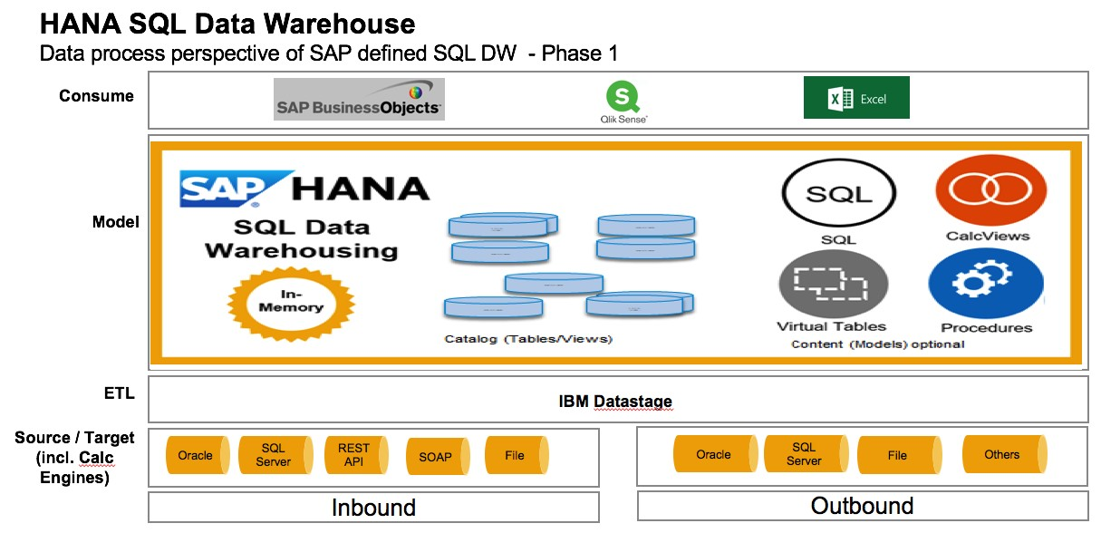
Figure 5. Proposed target Architecture (short term)
The proposed approach will have minimum impact on ETL and Reporting layer. Existing ETL logic in IBM InfoSphere DataStage will remain in place in the “to-be” landscape. DataStage will be populating HANA tables instead of tables in Netezza layer.

Phase 2 - Final Proposed Architecture
SAP Tool alignment with the SAP Roadmap, Leverage HANA Platform capabilities
As the next stage, the proposal is to review ETL layer and in a view to remove IBM InfoSphere DataStage by placing ETL logic into HANA Data warehouse. SAP HANA integration options are discussed later in the document.
In addition, Xtrac/IRT calculating engines shall be moved into SAP HANA, which will allow to streamline the data transformation process, provide single point of data truth and unify/consolidate reporting. It will also allow to reduce a number of DWH components reducing TCO.
Based on the discussions with COLT SAP proposes to follow two step approaches to address the proposed Architecture discussions.
Step 1- Technical Framework:
This phase will provide the different Architecture Frameworks for modelling the HANA Artefacts to cater the Outbound, Reporting, Persistence requirements.
Step 2 - Functional design mapping to the Framework
This phase will be performed at a later stage where detailed design workshops for Individual Interfaces are carried out and following the workshops SAP and COLT will map the Functional requirements to the Framework provided in this document.

Phase 2 - Proposed Target Architecture
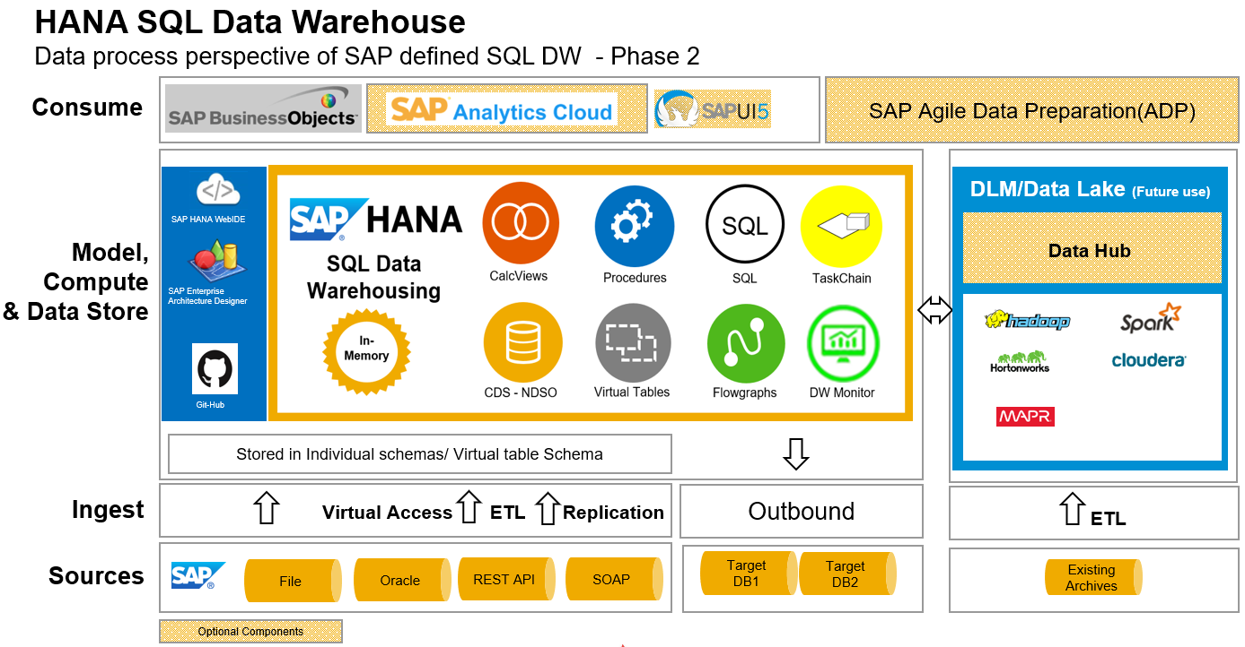
Figure 6. Proposed target Architecture

Data Provisioning
- Data Provisioning(DP) tools are used to extract data from various SAP and Non-SAP source systems.
- A variety of tools exists to perform this activity each having various feature support like
  - Virtualisation
  - Real time Replication
  - Transform capabilities and many more.
- Different technology recommendations apply, depending on whether your system landscape is SAP HANA–centric or, rather, comprises heterogeneous systems.
Below is the feature comparison for the proposed data provisioning tools (SDI, BODS and SLT) and Virtualisation tools for HANA target scenarios.
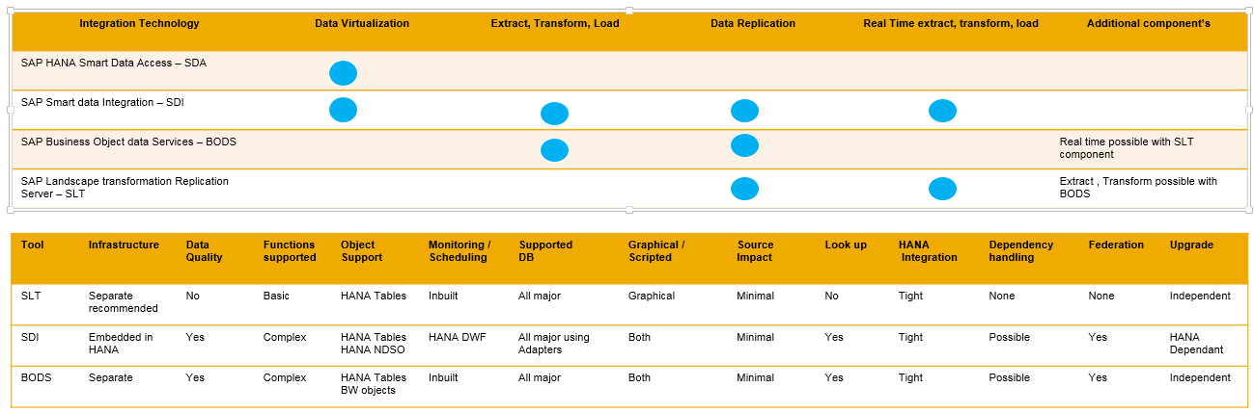
Figure 7. ETL Tool Comparison

SAP Smart Data Integration - SDI | SAP Business Objects Data Services - BODS
Supports ETL | ETL Software
Real-Time ETL Scenarios | Primarily batch Replication
SAP and Non-SAP source Systems | SAP and Non-SAP source Systems
On Premise or Cloud deployments | On Premise or Cloud deployments
Data Virtualization, Data replication | Real time replication possible while combined with SLT
Rich transform capabilities, functions | Rich transform capabilities, functions, or custom built functions
Rich set of Adapters to third-party databases as well as to cloud and Big data systems | Rich set of connectors to third-party databases as well as to cloud and Big data systems
Data Quality – SDQ can be considered | Data Quality
Replication is Trigger / Transaction log based depending on source system | SAP and non- SAP target systems
Integration with Data Hub possible | Integration with Data Hub possible
ADP leverages SDI, SDQ capabilities | -
Use Case:  Replicating data from SAP and non-SAP source systems into SAP HANA. | Use Case:  ETL and Interactive integration scenarios in heterogeneous system landscape

Considering the requirements and aligning to the SAP offerings for data provisioning for HANA Data warehousing we suggest evaluating the use of either of the below approaches
- SDI is the preferred tool for data provisioning to target SAP HANA systems.
- SAP BODS as skill set transitioning could be easier

To help select the right tool from the above recommendations consider,
- Real time requirements
- License implications
- Alignment to SAP Roadmap and Integration with other SAP tools
- Skill set transition
This document will focus on SAP HANA EIM as the recommended tool and subsequent section will provide details of the tools.

Enterprise Information Management(EIM)
The Enterprise Information Management (EIM) product portfolio provides ETL capabilities as a natural part of the product, this includes:
- Loading files of various formats into HANA tables,
- Copying source data from a remote system into HANA and keeping the data current (replication),
- Complex data integration problems where data needs to be transformed into a new structure, cleansed and matched against existing data.
Typical use cases are, for example:
- Make remote data visible as HANA virtual tables from any sources, not just databases – like SDA but with more adapters.
- To query data at SAP HANA speed the remote tables can be copied to HANA and kept current.
- An external source system provides data to be added into existing SAP HANA tables where the data must be transformed to match the target table structure.
- Transformations can include address validation, correction and standardization against the official post office data of the various countries, converting longitude/latitude geo coordinates into an address or vice versa, matching records using multiple rules to identify duplicates.
- Integrate SAP and non-SAP data into HCP for Cloud Apps.
To provide the maximum reuse, the entire solution is designed in a modular fashion with SQL commands as the lowest level of interaction.

Components Summary: 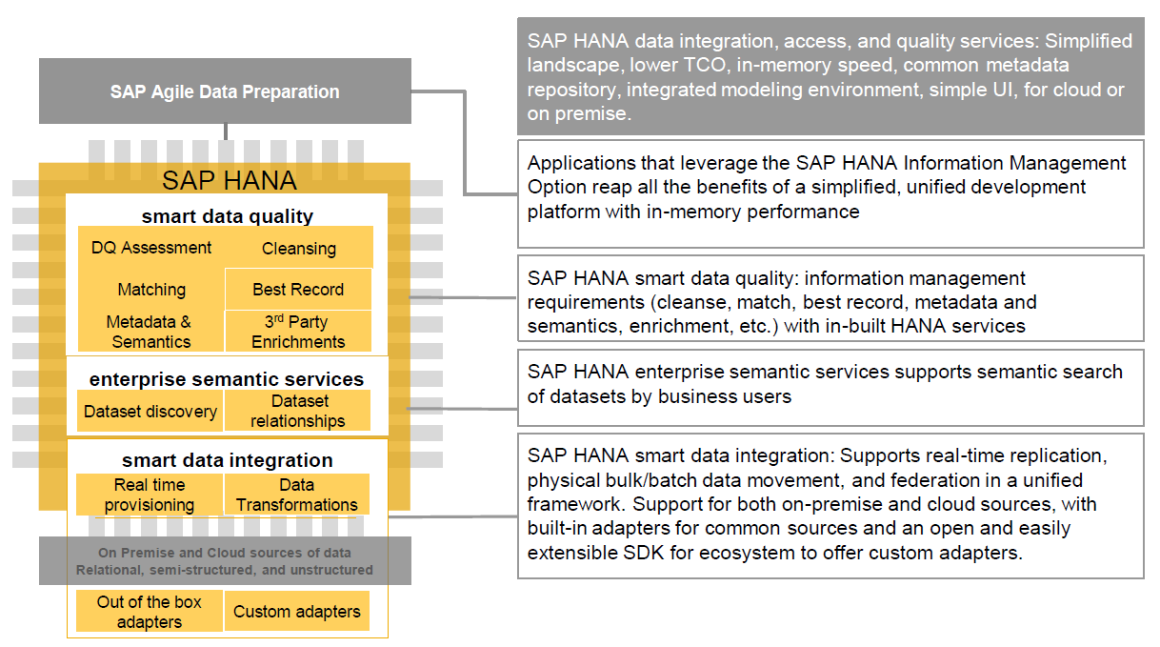
Figure 8.. EIM Component Overview
Adapters provide the connectivity to the various source system types.
All adapters are built based on a simple-to-use Java (or C++) Adapter SDK enabling partners and customers to build new adapters quickly.
These adapters can support reading and loading, provide access to metadata and can pull source data changes or even push change data proactively into SAP HANA. Adapters can also expose data via functions and procedures.
The HANA task framework can use any kind of SAP HANA object as source and target and owns the data movement and transformations.
Enterprise Semantic Search takes the adapter provided metadata and allows access via the graph engine or via SQL views, to enable the user searching the desired content.
The above components plus the respective WebIDE and Cockpit UIs are called Smart Data Integration.
With Smart Data Quality (additional license required) it is possible to get the reference data needed for the cleansing and to use the matching transforms.
On top of the EIM components the Agile Data Preparation solution is an additional product, enabling business users to take source data and manipulate it prior to analysing it.
The main advantage of this modular design is that every use case is a combination of components. For example, classic real-time replication means:
- use an adapter for connecting to the source
- create a virtual table to make the data visible in SAP HANA
- copy the virtual table content into a SAP HANA table
- put a remote subscription on the virtual table with the target being the SAP HANA table.

Smart Data Integration (SDI)
Smart Data Integration (SDI) is a feature rich ETL (Extract, transform and load) tool that is deployed directly onto SAP HANA. It supports real-time, batch and virtual data movement into SAP HANA and provides the ability for customers to build additional adapters if required.
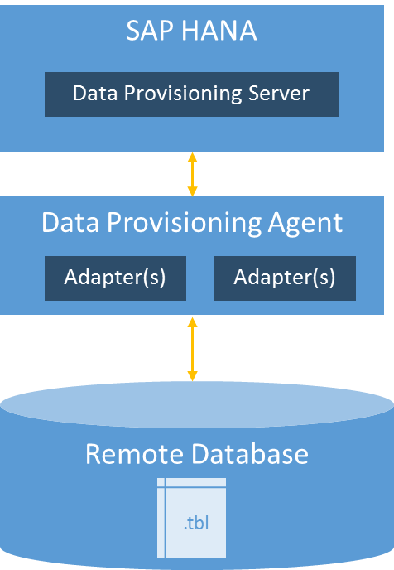
Figure 9..SDI Technical Architecture
Smart Data Integration (SDI) requires separate hardware & components to be deployed.
- Data provisioning server – a native SAP HANA process, provides native connectivity and connectivity to Data Provisioning Agent.
- Data provisioning agent – Managed by the data provisioning server, provides connectivity for all drivers that cannot run inside the data provisioning server and hosts the SDK adapters.

SAP HANA Data Provisioning Adapters
Data provisioning adapters can connect to a variety of sources and move data into SAP HANA.
The adapters in the following table are delivered with the Data Provisioning Agent and are limited to the COLT requirements.
Adapter Name | Description
OracleLogReaderAdapter | Retrieves data from Oracle. It can also receive changes that occur to tables in real time. You can also write back to a virtual table.
MssqlLogReaderAdapter | Retrieves data from Microsoft SQL Server. It can also receive changes that occur to tables in real time. You can also write back to a virtual table.
ExcelAdapter | Retrieves data from Microsoft Excel.  You can also access SharePoint source data.
FileAdapter | Retrieves data from formatted text files. You can also write back to a virtual table.  You can also access SharePoint source data, as well as write to an HDFS target file.
HanaAdapter | This adapter provides real-time changed-data capture capability to replicate data from a remote SAP HANA database to a target SAP HANA database. You can also write back to a virtual table. Use this adapter to extract data from an ECC on an SAP HANA source.
ODataAdapter | Retrieves data from an OData service. You can also write to an OData target.
SoapAdapter | This adapter is a SOAP web services client that can talk to a web service using the HTTP protocol to download the data. The SOAP adapter uses virtual functions instead of virtual tables to expose server-side operations as it closely relates to how the operation is invoked.

Modelling
Summary of various components

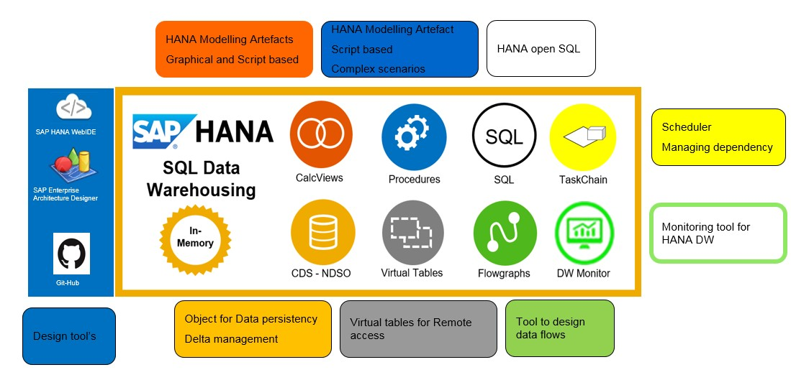
Figure 10. Modelling components view

SAP recommends the 5 Key Principles for HANA Modelling

Figure 11. Modelling Principles

Layered Architecture
A layered Architecture helps in several areas of the Modelling Lifecycle, below are the key points for each layer.
- Data Extraction –
  - This Layer is the core layer to persist the Inbound data from the various source systems.
  - To ease maintenance of the Source layers various Schemas will be created and data stored accordingly.
- Data Processing –
  - This layer is the layer for Business transformations, Data Persistency, Virtualisations and Cross application data processing
- Data Provisioning –
  - This layer is used for Reporting and Data feeds to the different outbound systems.

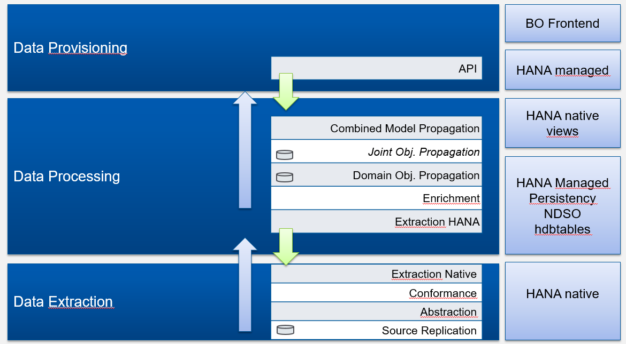
Figure 12. Layered Architecture

Schema Structure
- Source system-based schemas – Source data
- Business area-based schemas – Transformed data
- Reporting Schema – Reporting Objects/ Power user reporting
- Schema for Virtual tables

Package Structure
Packages:
Packages in HANA are used to store the Modelling Artefacts in a structured way. The package resembles a folder in the Windows environment.
To align with the layered Architecture approach and from ease of maintenance SAP recommends considering the below Package Structure
Parent Package = Business Area
Parent package = Cross Application
Within parent the below child nodes can be used
00-Masking:
SAP HANA provides inbuilt functions for data masking to help secure the confidential information
We recommend a separate package for views having Data masking functions
0 – Source:
- Source Package is used to store views built on source tables
- This view should be the direct replica of the table with no logic / cleansing
- The purpose of the views is to utilize the schema mapping function of SAP HANA to quickly adapt to new source systems, test data base etc.
- Conform:
- The views in this package will have cleansing logic, minor transforms (Not cross application), conversions etc.
- Extraction:
- The views in this package will store individual / cross functional transformed data for Persistency requirements example – Snap shot scenarios or L2/ L3 requirements
- Enrichment:
- The views in this package will store models that contain logic for data enrichment.
- Propagation:
- The views in this package will be used for Outbound Interfaces
- Reporting:
- The views in this package will be used for Reporting
- Virtual:
- The views in this package will be the ones built on Virtual table (Remote access)
- Tests:
- The views in this package will be the ones used for test testing scenarios.

Design Patterns

Logical layer Scenario (Virtual)
- SAP recommends using Graphical views where ever possible.
- For complex requirements Table functions are recommended over Scripted calculation views.
- Views on Local tables + Views on Virtual tables (Remote access) + NDSO
- Can cater to the following requirements
  - Master Data Consolidation - Dimension type
  - Hierarchies – Both
  - Currency conversion – Cube type
  - Unit Conversion – Cube type
  - Ranking – Cube type
  - Aggregation- Cube type
  - Multi-Dimensional requirements – Cube type with Star Join

Snapshot/ Persistence Scenario
SAP Provides various ways to cater the time travel requirements.
- History tables can be used to persist data to meet the time travel requirements. Time objects are required to track the changes over time
- Native Datastore objects available from SAP HANA 2.0 are available to meet the Snap shot requirements.
- The capabilities of using NDSO are given below
  - Handle insertion, update, and deletion of records.
  - Handle delta data processing to connected data targets incl. NDSO objects
  - Handle multiple inbound queues (NDSO InboundQueue) to load data from different sources
  - Provide an active/reportable data table (NDSO Active Table).
  - Keep track of data modifications (NDSO Changelog) to support the; rollback of a request, Delta data processing to connected data target.
  - Simplify the Flowgraph design (insertion, update, and deletion operations are controlled by the record specific RECORDMODE value)
  - Use Case
    - NDSO (Initial and Delta Data Load)
    - NDSO → NDSO (Initial and Delta Data Load)
    - NDSO (Integration with SAP HANA Calculation View)

Remote Access Scenario
- SAP HANA provides the functionality to report on Remote data using SDA – Smart data access.
- The prerequisites for this are given below
- Please note that usage of remote access could impact the overall performance of the reports and hence the use case for this scenario must be carefully evaluated.
- Remote Access can be used to develop a Test Framework to compare data between Netezza and HANA

Outbound Scenario
- Calculation views both Graphical and Scripted (Table function) can be used.
- Procedures can be used to generate on the fly delta files (Data Based, Time based) for Outbound Interface with help of helper tables.
- Consumption of Persisted data from NDSO.

SAP Data Hub (Optional)
SAP Data Hub is a data sharing, pipelining, and orchestration solution that helps companies accelerate and expand the flow of data across their modern, diverse data landscapes without storing the data on its own.
SAP Data Hub meets the governance and security needs of the enterprise, ensuring that appropriate policy measures are in place to meet regulatory and corporate requirements.
SAP Data Hub is not an ETL or streaming tool, it modernizes these functions and focusses on the integration of new technologies, operating in distributed landscapes (e.g. Hadoop cluster or public cloud storages) its main paradigm is to bring the logic where the data resides and to leverage the cluster compute power.
SAP Data Hub provides visibility and access to a broad range of data systems and assets; allows the easy and fast creation of powerful, organization-spanning data pipelines; and optimizes data pipeline execution speed with a “push-down” distributed processing approach at each step.
SAP Data Hub Relationship to SAP Analytics
SAP Data Hub helps drive value of analytics by optimizing the data pipeline with speed and security to enable organizations to act on the right information in the moment. SAP Analytics Cloud, a cloud based solution for all analytics (built on SAP Cloud Platform); will take advantage of powerful data orchestration capabilities with SAP Data Hub, allowing organizations to enhance powerful analytical use cases through the ability to control, manage and optimize their data environments.
SAP Data Hub relationship to SAP Data Services, SAP HANA smart data integration (SDI), and SAP HANA smart data quality (SDQ)
SAP Data Hub will leverage existing customer investments and
- Execute SAP HANA SDI/SDQ flowgraphs that run on SAP HANA boxes,
- Leverage SAP Data Services jobs that run on existing Data Services job servers.
- It will not replace their existing use cases.
SAP Data Hub is designed as a central place to orchestrate, monitor, and model integration flows, where SAP Data Services jobs, SAP HANA SDI and SDQ tasks, and Big Data flows can be brought together.
SAP Data Hub relationship to ADP
SAP Data Hub has some built-in profiling capabilities but can be complemented with SAP ADP as a self-service data preparation tool.
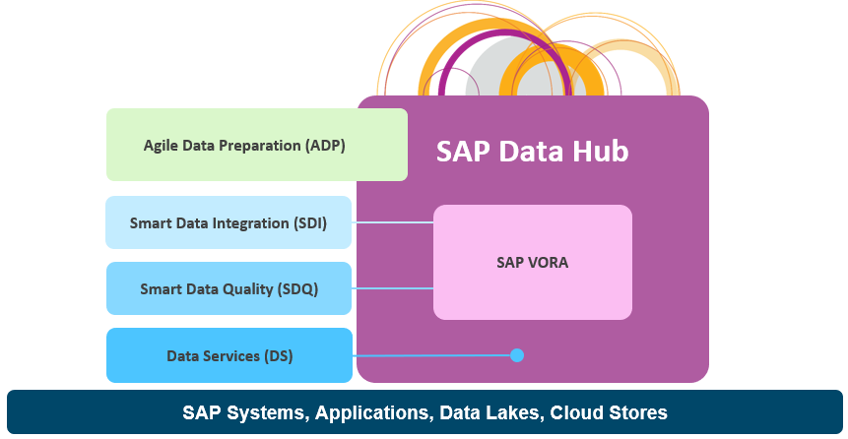
Figure 13. SAP Data Hub – SDI, SDQ, BODS, ADP relationship

Agile Data Preparation (ADP) (Optional)
SAP Agile Data Preparation is a self-service data preparation application that helps multiple user roles explore, integrate and transform raw data into actionable information.
It provides users with greater agility to respond to new data sources, business requirements and market opportunities.
Agile Data Preparation is an additional solution that leverages the EIM components enabling business users to take source data and manipulate it prior to analysing it.
ADP can be deployed on Premise or on Cloud.

Key Capabilities
Capability | Actions
Ingest data from variety of sources | Acquire data from any remote sources that SDI can access including NoSQL databases  Acquire data from flat files as CSV, Excel Files
Discover, profile data | Detects the content type of the data and profiles the data for easy understanding
Combine,Shape,enrich  or  Cleanse data | Allows easy transforms – trim, replace, split, data type conversions  Allows Aggregates or formulas without coding  Ability to cleanse and remove duplicates based on content type
Output data for downstream users | Ability to export results in HANA(Tables or Calculation views) as well as flat files
Data Steward access and improve the data quality
IT govern, analyse and optimize user processes | Allows IT to govern the users accesses and monitor their activities to optimise HANA platform

Visualization Layer
SAP recommend a Hybrid strategy for reporting combining SAP Analytics cloud and Business Objects Enterprise that leverages the strength of both platforms with minimal impact on existing developments. Third party tools can access the HANA objects and can be used for reporting. In case of hybrid scenarios SAP recommends the use of SAP Analytics Hub which provides a searchable catalog for all analytics content.
SAP Analytics Cloud brings together
- Data access
- Wrangling
- Discovery
- Visualization
- Analysis
- Prediction
- Forecasting
- Planning
- what-if
All augmented by artificial intelligence (AI) and machine learning (ML). These capabilities provide smarter more intuitive insight and allow organizations to always stay ahead for individuals, teams, and across the enterprise.
SAC can be used for data residing On Premise, On Cloud or in Files by using the below connection types
Live Data Connections –
- Are available for cloud and on-premise data sources
- Do not replicate your data in SAP Analytics Cloud
- Use existing data models for analysis
- Update your data visualizations and stories with new data in real-time
Import data Connections
- Are available for cloud and on-premise data sources
- Replicate data within SAP Analytics Cloud
- Create new data models through the SAP Analytics Cloud Modeler
- Update your data visualizations and stories when refreshed
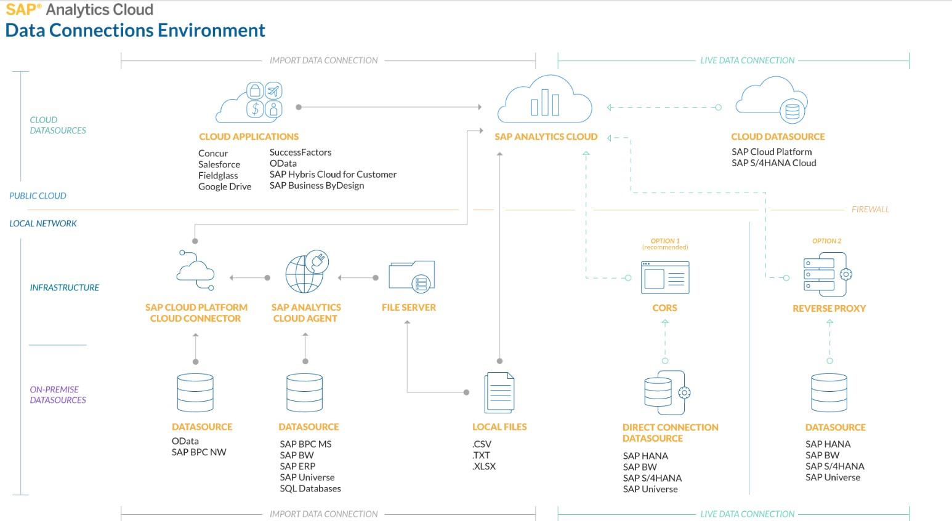
Figure 14. SAP Analytics Cloud – Connection Environment
SAP Analytics Hub(Optional):
SAP Analytics Hub is a new software as a service (SaaS) offering that aims to address the
challenge of limited analytics adoption. SAP Analytics Hub empowers more business users to
make better decisions with the right analytics available to the right user at the right time.

Risks and mitigations
- Evaluate the EIM capabilities against BODS for stability purposes.
- Due to the complexity involved in Big Bang shift of all processes, Follow Business area wise rollout while moving to the proposed Architecture.
- Licenses for various components should be considered and discussed with SAP licensing teams
- Archiving Strategy should be established during the detailed design to avoid the Memory footprint for infrequently used data/ data required for Audit reasons etc.
- Data Lake requirements are planned for future use and hence the supported offerings, version compatibility at that point in time must be evaluated.

Hosting Options
Cloud and On-Premise options are available for Data Warehouse deployment.
In addition, Cloud deployment can follow three main models – IaaS, PaaS and SaaS:
- IaaS model assumes Colt takes full responsibility over maintenance and operation of the deployed system, whereas service provider is responsible for the platform – i.e. availability and performance of underlining infrastructure. Examples of IaaS is Amazon WS, Microsoft Azure. Packaged solutions (like standard HANA database) can be deployed as matter minutes (however additional infrastructure elements, such as networks and security are typically more complicated and require more time to deploy)
- PaaS model offers platform for developing applications, where provider assumes full control over underlining platform including database. PaaS option does not fit well Colt requirement and DWH deployment model as most of the data sources are currently deployed on premise.
- SaaS model offers even less control over deployed solution than PaaS (example – SAP Concur); SaaS option does not fit Colt requirement and DWH deployment model as most of the data sources are currently deployed on premise.
Following discussion with Colt team, it became evident that IaaS deployment model can offers certain advantages over the Colt’s current deployment on premise model. Sandbox / PoC system can be deployed in a short time scale using existing AWS agreement and be connected to existing Colt’s datasource / ETL systems.

Networking
If Data Warehouse is hosted on Premise, the proposed approach for Network / Network Zoning setup is to utilize existing setup.
If Data Warehouse is hosted in cloud, network design needs to be performed as a separate exercise to ensure Network Zoning and encryption are set in accordance with Colt’s security principles and sufficient data bandwidth is available.

Assumptions, risks and mitigations
- Current network infrastructure has sufficient capacity to extend for DWH solution,
- including available bandwidth;
- DWH datasources can connect to DWH;
- Lead times and operational costs need to be confirmed with relevant support teams;
- Networks and firewalls setup need to be identified.

Virtualization
SAP HANA systems can be run on virtual machines with restrictions to the hypervisor (including logical partitions).
In addition, SAP announced support for VMware hypervisor, as the first technology supported to partition a SAP HANA server into smaller partitions / VMs and has further extended its support to run SAP HANA in a virtualized / partitioned (multi-tenant) environments, by adding additional scenarios and technologies supported.
SAP only supports virtualization of SAP HANA on validated single-node SAP HANA appliances or through SAP HANA tailored data center integration verified hardware configurations.
In general SAP HANA virtualized is sized the same as non-virtualized SAP HANA deployments. In other words, for sizing the virtual machine (VM) the CPU/memory ratio as used for native, non-virtual sizing is considered to ensure locality of memory access on the underlying hardware resources.
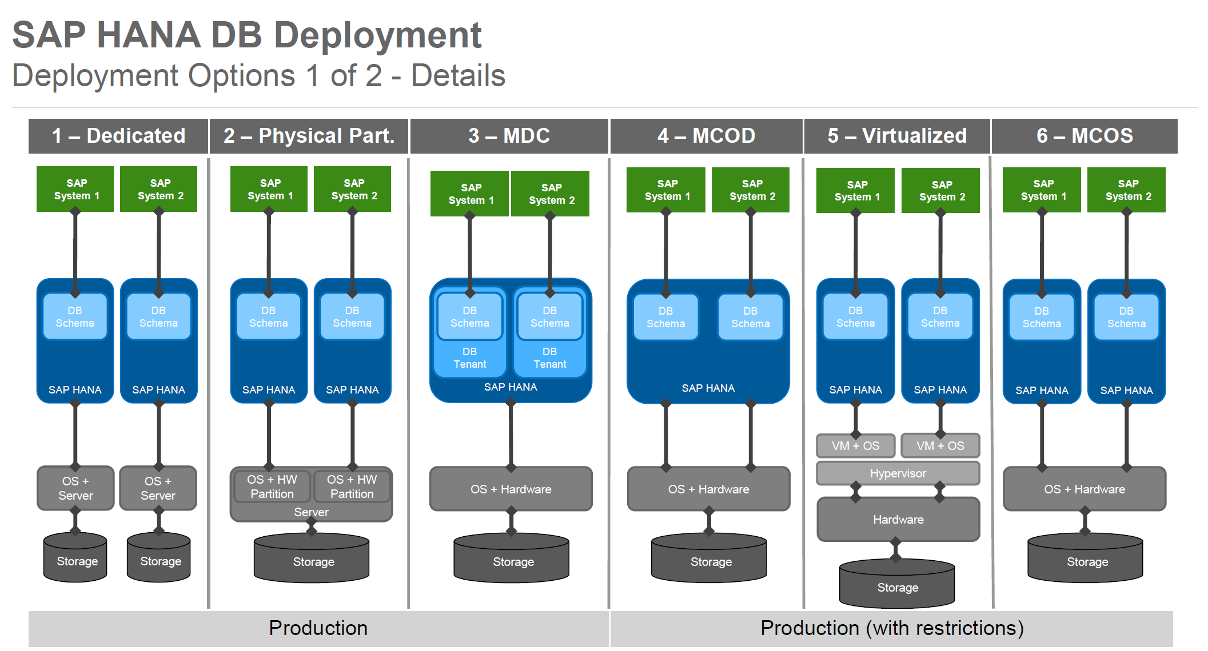
Figure 15. SAP HANA virtualization options
Based on the discussions taken place during the workshop, dedicated hardware (option 1, possibly combined with option 3) of VM deployment (option 5, possibly combined with option 3) are available to Colt. The decision will be based on infrastructure available and hosting choice.

Assumptions, risks and mitigations
- Cloud based solutions typically offer VM based deployment (exceptions are possible depending on cloud vendors)
- Database size is a significant factor in making virtualization decision (i.e. for example the maximum size of a virtual SAP HANA instance is limited CPU-wise by the maximum size of a virtual machine on VMware vSphere 6.5 release, which is 128 vCPUs on 4 Sockets (4 sockets on up to 8 socket hardware), and 4TB of RAM) – accurate sizing must be complete before virtualization approach is chosen

HA/DR (Availability and Continuity)
SAP HANA platform provides HA/DR capabilities with multiple options to select RTO (recovery time objective) and RPO (recovery point objective) timelines based on planned and unplanned downtimes.
High availability of the SAP HANA platform is achieved by eliminating single points of failure (fault tolerance) and enabling the resumption of system operations after system outage with minimum business loss (fault resilience). The platform provides different levels of defense against redundancies to achieve HA at the hardware, network, and data center layers. It also provides disaster recovery support and fault recovery support mechanisms to enable data centers to resume normal business operations as quickly as possible.
It is envisaged that DWH will be providing similar HA resilience as the current system. To be able to achieve this, secondary HA HANA system can be installed acting as Active – Active pair (available as of HANA 2.x)
In this method, all the data that is written to the persistence layer (data and log volumes) by the primary (Production) HANA system is replicated to a secondary system (either in the same of secondary data center).
As alternative solution, HANA host of the secondary location can be used for other SAP HANA systems (Testing environment) depending on hardware solution; in this case secondary HANA system is in passive mode and RTO times are increased.
The following diagram shows such scenario:
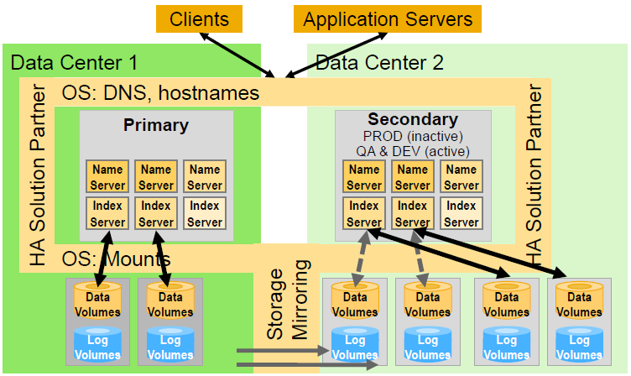
Figure 16. SAP HANA HA/DR options
Storage replication offers both synchronous or asynchronous replication options, but synchronous replication should only be used when the distance between the primary and secondary site is no more than 100 km. Otherwise due to the longer distances between the locations, the latency times for writing the redo log may increase.
In addition, DWH solution offers scale-out option where DWH can be deployed using multiple nodes forming single SAP HANA instance.
The failover process happens on the host level, so failure of a single service or process won’t trigger the failover. When the primary host fails, the standby host will take over its lock on the data pool and continue working from there, so there will be no data loss.
The following diagram shows such scenario:
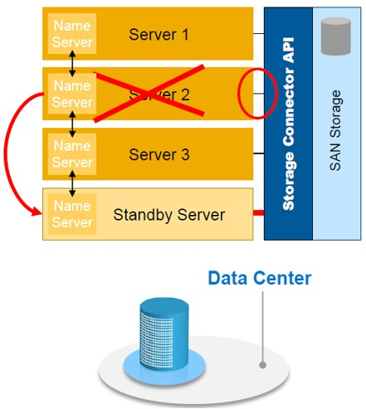
Figure 17. SAP HANA HA for scale-out
Actual deployment options will depend on RTO, RPO requirements, hosting decision and database size. Recommendation is to have further discussion once the above topics are clarified.

Scalability
DWH solution provides several different options for scalability. For in-memory scalability scale-up and scale-out options are available. In a scale-out environment, data is distributed amongst the nodes. In case of scale-out, Colt will have to partition own data. For scale-out, you will need one “hot-spare” node, and one master node, which is used for configuration tables and calculations. For example, if five nodes are deployed, only get roughly three for usable database. Some of the additional scale-out nodes can be utilized as “extension nodes”, where requirement for processing / spare memory is significantly reduced.
Normal approach is to scale-up first (2-4TB are common scale-up HANA options) before considering scale-out to avoid SAN the complexity of managing a cluster.
Note that all scale-out nodes need to be same in size, so to scale-out to 8TB from 4TB scale-up system, the 4TB would need to be replaced by 5x2TB nodes. Dynamic tiering (discussed later in the document) shall be considered as alternative option at this point.
In addition to In-Memory scaling, for DWH there the option of the IQ/Hadoop “Cold” store, where you can store cold data at very low cost. Scale-out should be considered before “Cold” for performance reasons.
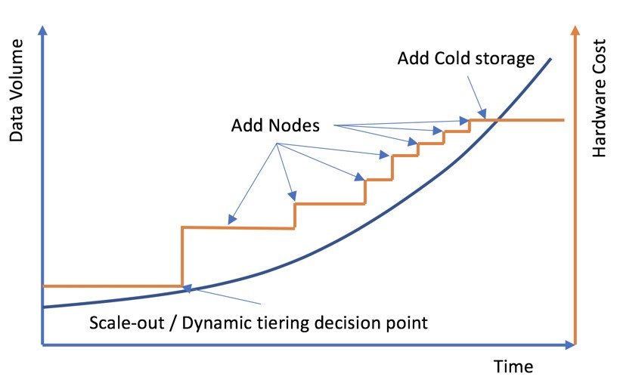

Load/Unload a Column Table into/from Memory
Under normal circumstances, the SAP HANA database manages the loading and unloading of tables into and from memory automatically, the aim being to keep all relevant data in memory. However, you can manually load and unload individual tables, as well as load table columns if necessary, which can be done either using Administration Tools (like HANA studio) or SQL commands.
In addition, you can use the Unused Retention Period feature to automatically unload objects from memory which are not being used after the specified time.
Link - https://launchpad.support.sap.com/#/notes/2127458

Table partitioning
The partitioning feature of the SAP HANA database splits column-store tables horizontally into disjunctive sub-tables or partitions. In this way, large tables can be broken down into smaller, more manageable parts. Partitioning is typically used in multiple-host systems, but it may also be beneficial in single-host systems.
When a table is partitioned, the split is done in such a way that each partition contains a different set of rows of the table. There are several alternatives available for specifying how the rows are assigned to the partitions of a table, for example, hash partitioning or partitioning by range.
The following are the typical advantages of partitioning:
- Load balancing in a distributed system
Individual partitions can be distributed across multiple hosts. This means that a query on a table is not processed by a single server but by all the servers that host partitions.
- Overcoming the size limitation of column-store tables
A non-partitioned table cannot store more than 2 billion rows. It is possible to overcome this limit by distributing the rows across several partitions. Each partition must not contain more than 2 billion rows.
- Parallelization
Partitioning allows operations to be parallelized by using several execution threads for each table.
- Partition pruning
Queries are analyzed to determine whether they match the given partitioning specification of a table (static partition pruning) or match the content of specific columns in aging tables (dynamic partition pruning). If a match is found, it is possible to determine the specific partitions that hold the data being queried and avoid accessing and loading into memory partitions which are not required.
- Improved performance of the delta merge operation
The performance of the delta merge operation depends on the size of the main index. If data is only being modified on some partitions, fewer partitions will need to be delta merged and therefore performance will be better.
- Explicit partition handling
Applications may actively control partitions, for example, by adding partitions to store the data for an upcoming month.

Dynamic Tiering
Dynamic Tiering for HANA is another discussed option, which allows data to be persisted on a warm store, further reducing HANA footprint.
SAP HANA dynamic tiering adds the SAP HANA dynamic tiering service SAP HANA system. You use this service to create the extended store and extended tables. Extended tables behave like all other SAP HANA tables, but their data resides in the disk-based extended store.
The application automatically determines which tier to save data to: the SAP HANA in-memory store (the hot store), or extended storage (the warm store). When you use SAP HANA to place hot data in SAP HANA in-memory tables, and warm data in extended tables, highest value data remains in memory, and cooler less-valuable data is saved to the extended store. The extended store can reduce the size of your in-memory database.
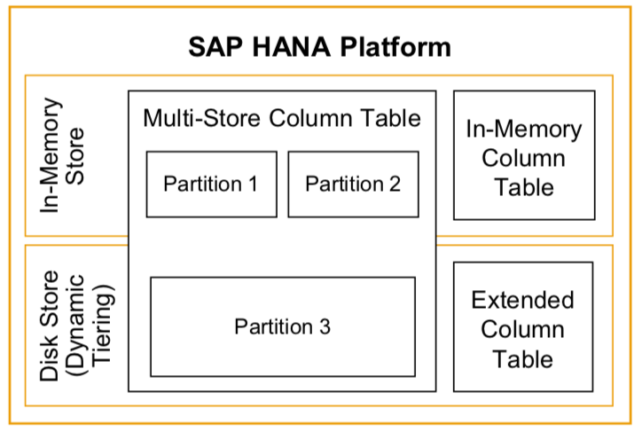
SAP HANA dynamic tiering can be installed each on a dedicated server or on the same server – decision would be based on hardware resources utilization and virtualization approach used.
Details for the Dynamic Tiering are available from https://help.sap.com/viewer/fb9c3779f9d1412b8de6dd0788fa167b/2.0.02/en-US/0138ab1f826449f88f38e2dc5788823e.html
Additional information on Dynamic Tiering sizing is available from here: https://help.sap.com/viewer/fb9c3779f9d1412b8de6dd0788fa167b/2.0.03/en-US/f38d5e17734945f5bc1afbe3a3da48d5.html
Details for Hadoop integration are available from https://help.sap.com/viewer/c618c36d79e34077a680bac61affc8b7/2.0.2.0/en-US

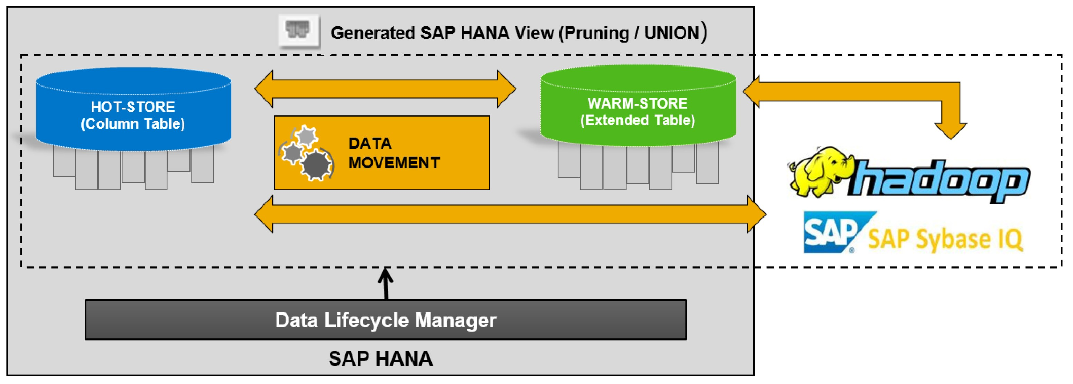
Figure 18. SAP HANA Scalability
- Functional restrictions with Extended tables
https://help.sap.com/viewer/269740c67eca42a3b4ffbd376b406fbe/2.0.03/en-US/e277bd261b04467eba3a4dfd892e7c84.html

- Performance Tuning options for DT
https://help.sap.com/viewer/269740c67eca42a3b4ffbd376b406fbe/2.0.03/en-US/4dfe51d3d2d043e9a2b633931e337e23.html
https://help.sap.com/viewer/269740c67eca42a3b4ffbd376b406fbe/2.0.03/en-US/9899e6b8de5e4e3f8a5351fd86986c14.html

Proposed approach
Database size is the main factor contributing to the scalability approach design. Reducing solution complexity allows lower TCO. Proposal is to have single scale-up node for database size of 4.6TB; moving to dynamic tiering for up to 12TB system and cold storage (i.e. Hadoop) if larger data volumes are expected.
As an alternative to dynamic tiering, scale-out solution should be considered as an option.
Note that Non-Volatile Memory (NVM) is supported by SAP HANA as of HANA2.0 SP03, which is expected to reduce hot memory cost, thus allowing larger scale-up systems.
During data modeling process, recommendation is to give a careful consideration to large tables partitioning options

Assumptions, risks and mitigations
- Depending on reporting requirements both in-memory and persistent data can exceed initial estimates.
- It is important that any development on DWH is tested against “live” data volumes

Sizing
Data Warehouse sizing is one of the main factors when deciding on scalability, data tiering and virtualization options.
Current Netezza production system is 15+ TB in size. It is expected that migrating from traditional row-based database (Netezza) to column-based database (HANA), high levels of data compression can be achieved. However exact levels of compression depend of data structure (data types, cardinality, etc.) and can vary by a large margin
During PoC, a representative sample of Netezza data was loaded into HANA system providing average 3.4 compression ratio, which results in estimated 3.6TB data footprint, 2.1TB of which is CDR-Raw data.
In addition, staging tables are having around 0.6TB footprint. With additional conservative estimate for error margin of 0.3TB and standard compute size recommendation of equal to data footprint, the in-memory database size is expected at 4.6TB


Proposed approach
Based on the above PoC results, the proposal is to allocate CDR-Raw to Dynamic Tiering layer, resulting in 4.6TB HANA in-memory system with at least another 4TB allocated to DT layer.
Please note that Hardware vendor will provide exact details for the HANA appliance based on the required memory.

Assumptions, risks and mitigations
- Assumption is that CDR-Raw date is infrequently used and is not required for end-user reporting, therefore assigning it to DT layer will have little overall performance implications.
- Risk is that performance impact of storing CRD-Raw data is not quantifiable at this stage; the alternative solution is to have the data in memory, thus increasing HANA memory requirement to 8TB (5x2TB scale out solution would be an option in this case).
- Impact of data remodeling and moving ETL layer into HANA is unknown and may result in either increased or decreased data footprint.
- Expectations are that Dynamic Tier data compression is the same as in memory (as the structure of data remains the same when moved to DT). In addition, DT compression is is not as critical as in-memory as the data is stored on cheaper storage

Tiers
Multitiered landscape allows staged promotion of custom development to Production. SAP best practice approach is to have at least three tiers – Development, Test and Production. Where data sources are not available to follow the same concept, production data can be loaded into non-Production DWH, however data security needs to be considered:
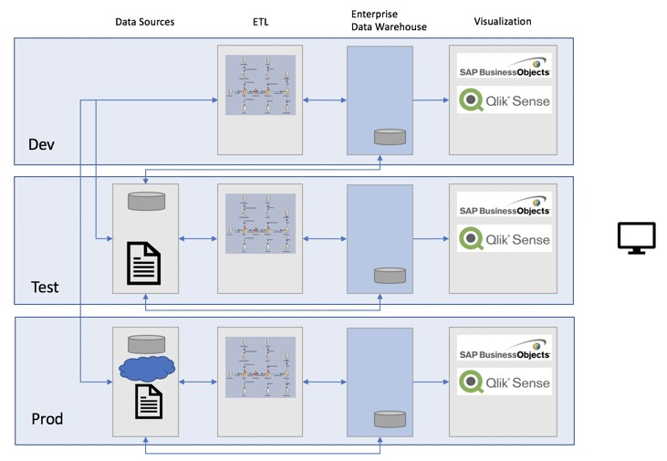
Figure 19. DWH tiers

Proposed approach
at least three environments for DWH: Development, Test and Production.
Additional fourth PoC / Sandbox systems can be used as standalone environment.

Assumptions, risks and mitigations
- Production and Test environments should be sized identically
- Development can be smaller in terms of available hardware resources.
- Typically, not all data sources the reflect three tier approach; in this cases DWH can be connected cross-tiers

Lifecycle Management
SAP HANA application lifecycle management is provided to support all phases of an SAP HANA application lifecycle, from modeling your product structure, through application development, transport, assemble, and install.
When you develop SAP HANA applications, you must decide on the transport scenario that you want to use and its impact on the setup of the transport landscape, as well as on whether you want to use change recording.
Two options are available to support transport of HANA Development objects: native SAP HANA and SAP NW CTS+ (controlled via Solution Manager)
Current change management process utilized by Colt can remain as it is, as it is not integrated into the DWH.

Proposed approach
Native SAP HANA transport is a sufficient solution for DHW
Further details on SAP HANA ALM can be found here:
- https://help.sap.com/viewer/a4d43a319ecf464e9d838454a6bdb9ad/2.0.00/en-US/91f4bf31ae2f4457819c79c3ce741e83.html

Infrastructure Security
SAP HANA supports encrypted communication for network communication channels. Recommendation is using encrypted channels in all cases where your network isn't protected by other security measures against attacks such as eavesdropping, for example, when your network is accessed from public networks.

Assumptions, risks and mitigations
Encryption and SSO requirements for clients, data sources (each) still require further clarification from Colt
- Infrastructure security – encryption, certificates
- Security between Hana and the data sources
- Use of certificates for movement of data
- Not required for internal data traffic sources
- Confirm with Colt security team if internal encryption of data required

Authentication & Authorization

Authentication and single sign-on
Access to SAP HANA data, functions and applications requires authentication.
SAP HANA offers several authentication options, which can be configured per user. For password login, a password policy governs change frequency, password complexity and other password related security settings. Several standard based single sign-on (SSO) options are available: Kerberos/SPNEGO, SAML, SAP logon and assertion tickets, X.509 certificate.

User and identity management
SAP HANA provides tools for user administration and role assignment, as well as adapters for SAP Identity Management and SAP Access Control, which allow integration into existing user provisioning infrastructures. LDAP group integration for authorization purposes is also provided. To connect custom user provisioning solutions, an SQL interface is available.
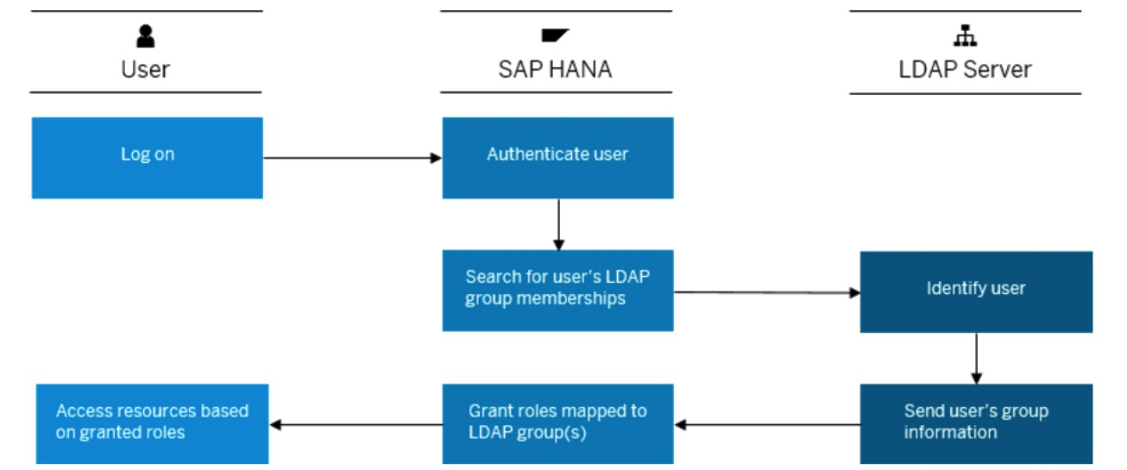
Figure 20. SAP HANA Authentication (LDAP)

Authorizations

As-Is process
Currently authorizations are mainly handled at two layers:
- Reporting layer i.e. Business Objects
- Netezza layer-In this layer for security customized tables have been defined in which security has been defined at field level. As per the discussions with business security complexity is low. Currently authorizations mainly based on hierarchy. This is a nine-level hierarchy. Security is mainly based on country code.

To-Be process
To-be authorizations are mainly handled at two layers:
- Reporting layer i.e. Business Objects
- HANA layer-Customized tables will be defined as defined in Netezza and accordingly security needs to be handled.
SAP HANA’s comprehensive authorization framework provides highly granular access control. Roles are used to bundle and structure privileges into sets of privileges for dedicated user groups. Privileges are based on standard SQL object privileges and SAP HANA-specific extensions for business applications.
The security model at Colt will be a combination of System Privileges (E.g. Admin functions), Object privileges (E.g. SELECT, UPDATE, CREATE) and Analytic Privileges (E.g. View restrictions).
The security model for the Colt BI solution will be based on a hierarchy & combination of the above privileges that will need to be refined during the transition phase.
The SAP HANA Security Guide provides detailed information on the HANA security functions here:
- https://help.sap.com/viewer/b3ee5778bc2e4a089d3299b82ec762a7/2.0.01/en-US/db9d62f5bb5710148729a6f9b865ef1d.html

Analytic Privileges
Analytic Privileges grant users specific access to the data based on their business role within a SAP HANA View. For example, this method could be used to restrict users, so they only see specific cost centres from in a HANA view. These privileges only apply at a view level and do not restrict what the user sees if they access the base table.

Data Masking
In addition to Analytic Privileges, SAP HANA can apply “Data Masking” on SQL views and Calculation views. When using Analytic Privileges, a user will not see data they are not authorised for, in certain circumstances (E.g. HR data) this could lead to potential data inconsistencies (As the user would not see all employees, only the ones they had access too).
With Data Masking, all data is displayed but where a user is not authorised for the data they would see ‘###-####’ etc.
Data Masking is only recommended in highly regulated systems/scenarios and may not be applicable for the Colt’s DWH platform.

Business Use Case in scope of High Level Design:

Snapshot reporting in SAP HANA (BI)
Snapshot reporting involves getting the information of i.e. work orders and classification table from ECC, Purpose is to gather the information of when a task snapshot time and what information it should gather for snapshot to determine whether the work is done on time or got delayed.
SAP HANA has several options to fulfill the Snapshot scenarios
Option 1 – Use of SAP Native Datastore Object(NDSO)
SAP HANA 2.0 introduces the NDSO (Native Data Store Object) which provides the function for Snap shot use case in addition to other use cases. NDSO’s can be loaded with IBM Datastage (Please check the prerequisite versions) and is the recommended option for fulfilling the Snapshot requirement.
https://help.sap.com/viewer/DRAFT/1e4f857a22aa477081d41d3b6fa48d99/2.0.3.0/en-US/e7555158f7ce43f3b6fb5ab09de5cad3.html?q=snapshot
https://help.sap.com/viewer/DRAFT/1e4f857a22aa477081d41d3b6fa48d99/2.0.3.0/en-US/bdd07df3399a4a989f9bf3bc2f02c3e9.html
Option 2 – Use of History tables
SAP HANA, we have the possibility to implement the concept of time travel, allowing to query the database retrospectively and ask for how the data looked at a specific point back in time. This means we can easily view both the current and historic views of the data.
We can achieve this by writing procedures to get the snapshots of work orders based on the forward offset and backward offset days and time for work orders.
For the daily snapshot, each snapshot can be generated with reference to the previous day snapshot and movements for the day. If there are no movement documents generated for a given date, the previous snapshot can be copied over. But in this process, the no of records generated would be quite high, I would not recommend this option.
You can also agree with the business users to store the snapshots for a specific time (6 months - 1 year) and delete all the previous snapshots to reclaim the memory.
For COLT business use we can explore the functionality in SAP HANA and with this we can trace the data changes along with timestamps, concept is very similar to CDC (Change Data Capture).

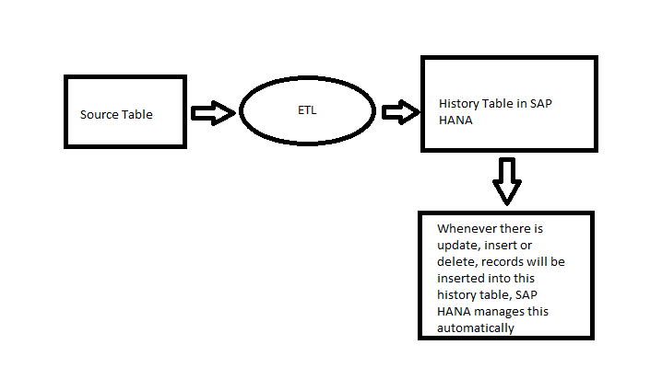
Figure 21. Snapshot approach
SAP HANA uses a concept of insert only. Data that is being overwritten or deleted is marked as ‘invalid’ (via a To and from value) so it’s not the current version anymore. However, we can access the invalid records to allow our point in time/snapshot reporting concept.
SAP HANA gives us the flexibility for both current view and point in time reporting through the history table, meaning both types of requests from the business can be catered for without the need for any remodeling or data reloads.

Reporting on source system data using SAP HANA (BI)
COLT Power analytics users to have direct access on source DB, to do data discovery
We can achieve this through virtual tables in SAP HANA and creating Calculation views (data model) is a structured representation of HANA database views used in SAP HANA for SAP and Non-SAP source systems. Calculation views built on top of virtual tables provides direct access to source system business data using standard SQL or OData requests.
SAP HANA Smart Data Access (SDA) provides the option to federate queries over multiple data sources and to access data stored in external databases (incl. external SAP HANA databases) by a query or a calculation model in SAP HANA.
The smart bit in SDA is that the SAP HANA query processor is aware of the technical capabilities of the external data sources and creates queries accordingly. This includes choosing join strategies, filter push-downs and e.g. group by push-downs. Whether or not any of these operations are done for a specific query depends on the capabilities of the data sources, the expected data volumes and on the specific query.
We must check how the actual execution looks like for all of COLT queries.
In SAP Web IDE, we can use a form-based editor to create virtual tables. Virtual tables allow COLT to access objects in other databases without having to replicate database tables to SAP HANA.
The SAP Web IDE supports creating virtual tables with a code editor and a form-based editor. Creating virtual tables with a form-based editor helps, for example, to create virtual tables when you are not aware of the syntax to create them with the code editor. After creating the virtual tables, you can use them as data source in SAP HANA Calculation Views.

Persistence Layer
Virtual tables can be created in any schema in SAP HANA database like local tables. The persistence layer includes local tables, activated calculation views and metadata (structure of the object and remote connection details) of the virtual table. Only the metadata of the virtual table is persisted in SAP HANA, the data in the virtual table continue to stay in the remote database. Virtual table can be accessed in SQL script and used in Calculation views like local tables in SAP HANA database.

Query Processing
The SQL engine is responsible for processing the SQL queries on virtual data models using both local and virtual table. The SQL parser of the SQL engine validates the syntax and semantics of the SQL query. The SQL optimizer then creates a single acyclic execution model by decomposing the calculation views. A rule-based optimizer is engaged to push the filter to the table level, combine multiple projection/aggregation/join steps into one projection/aggregation/ join step and identify query fragments that need to be executed in the remote SDA system. A cost-based optimizer estimates cost of each operation to derive the most cost-effective execution plan and the SQL executor then delegates the operations to SAP HANA internal engines (for local tables) and forwards the SQL fragments to remote database for execution.
The SQL optimizer is aware of the capabilities (and shortcomings) of the remote database and uses statistics of the virtual table to optimize remote execution. It also uses the following techniques to reduce data transfer across the network.
Predicate Push down: The filters/constraints part of the calculation view and SQL query are automatically added to SQL fragment to be executed in the remote server to reduce the data selection from the remote database.
Join Relocation: The statistics of the local tables and virtual tables (e.g. no of records and size of columns) are used to determine the most effective place to perform the join. Data movement can occur in either direction to perform the join efficiently. For example―join between two virtual table on the same remote database will be executed in the remote database, while join between two tables (one smaller & one bigger) will occur at location of the bigger table (SAP HANA or remote database) and the smaller table will be copied over (to the location of bigger table) to perform the join.
Functional compensation: If the remote database does not support a SQL operation which is supported in SAP HANA, that SQL operation on the remote dataset will be performed in SAP HANA during SQL execution.
Remote Caching: If result materialization/caching is supported by the remote sources (like Hadoop Hive data sources), SAP HANA can trigger the caching process on the remote source to avoid the repetitive execution of the same query in the remote system.
This behavior is easily managed by including a hint clause (e.g., WITH HINT (USE_REMOTE_CACHE)) part of the SQL query.

Building virtual data models
Building virtual data models with SDI virtual tables is like that of local tables with the following exceptions:
- SDI virtual tables are only supported in Calculation Views (no support for Attribute and Analytic views).
- One or more virtual tables from the same remote source must be isolated into one or more (virtual table exclusive) calculation views. These calculation views must not have SAP HANA native objects (i.e., tables, analytic views, attribute views, etc.) or virtual tables from another remote source. These calculation views must be set to execute in SQL engine.
- One more calculation view may be used to combine results (union, join etc.) from virtual table exclusive calculation views (from #2) and calculation views based on local tables to provide unified access to data from multiple heterogenous data sources.

Reporting and Visualizations
SAP HANA virtual models can be used in SAP Business Objects BI tools and Analytics on Cloud. SAP HANA virtual data models can also be consumed by third-party BI tools (Tableau, MicroStrategy, Cognos, QlikView etc.) supporting JDBC/ODBC data access. SAP HANA also support development of HTML5 based applications & visualizations using the in-built XS Server and XS Advanced framework.

